VLOGGER

USER MANUAL

1. NAVIGATION

START PAGE

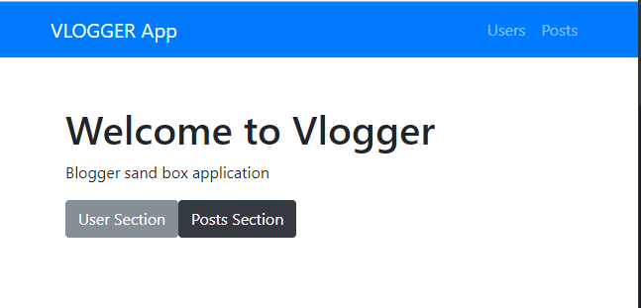

Basic navigation from the splash page is separated into two sections.

-User Section

-Posts Section

1. Users

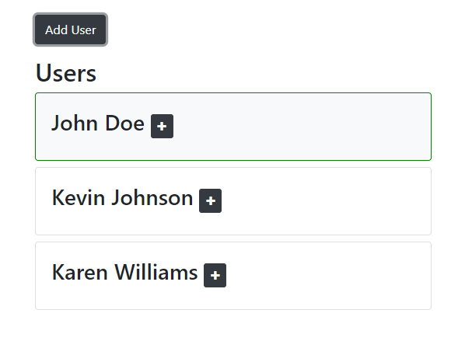

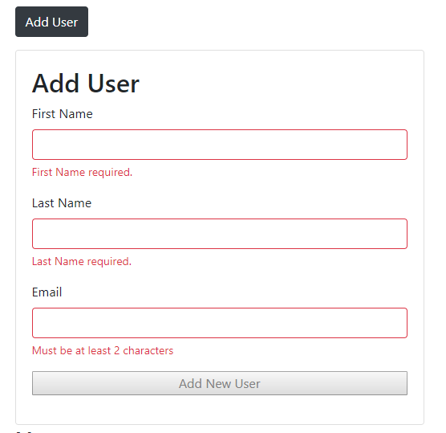The Users section contains user name, email and registration details. New users can be added by clicking the Add User Button.

User details are validated for correct text information. Email addresses are checked for correct domains and string values.

When a new user is added, today’s date is set as their joined date.

\*\*Please note that in this version of Vlogger, user information is only stored locally while the program is running.

Future updates will include user validation and cloud group security.

1. POSTS

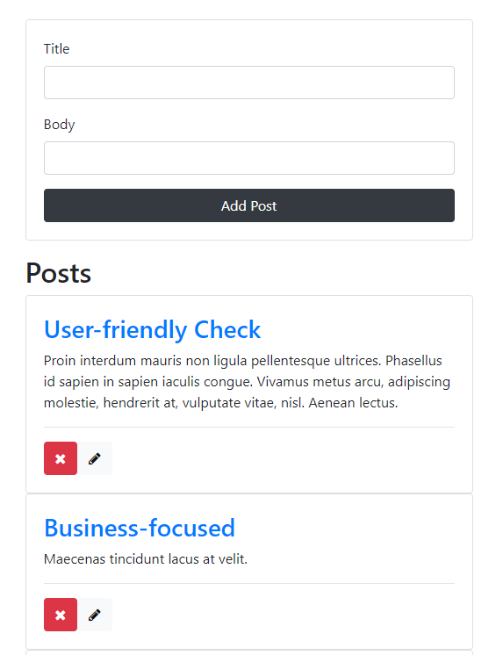Posts section loads posts from the database. Each post is loaded sequentially from server.

New Posts can be added by entering a title, text body, and then clicking the

Add Post Button.



DELETE POST

The red X Icon will delete a post. The user is prompted to check if they are sure and then the post is removed from the post list and server.



EDIT

Post can be edited by clicking the pencil icon. The form is then converted into an editing panel with a yellow button to denote that changes will update a current post thus overwriting it on the blog page and server database.

